AI ASSISTED CODING

LAB EXAM -1

TASK-1:

TO FIND WHETHER THE GIVEN NUMBER IS PALINDROME OR NOT

CODE SCREENSHOTS

WITH OUTPUT: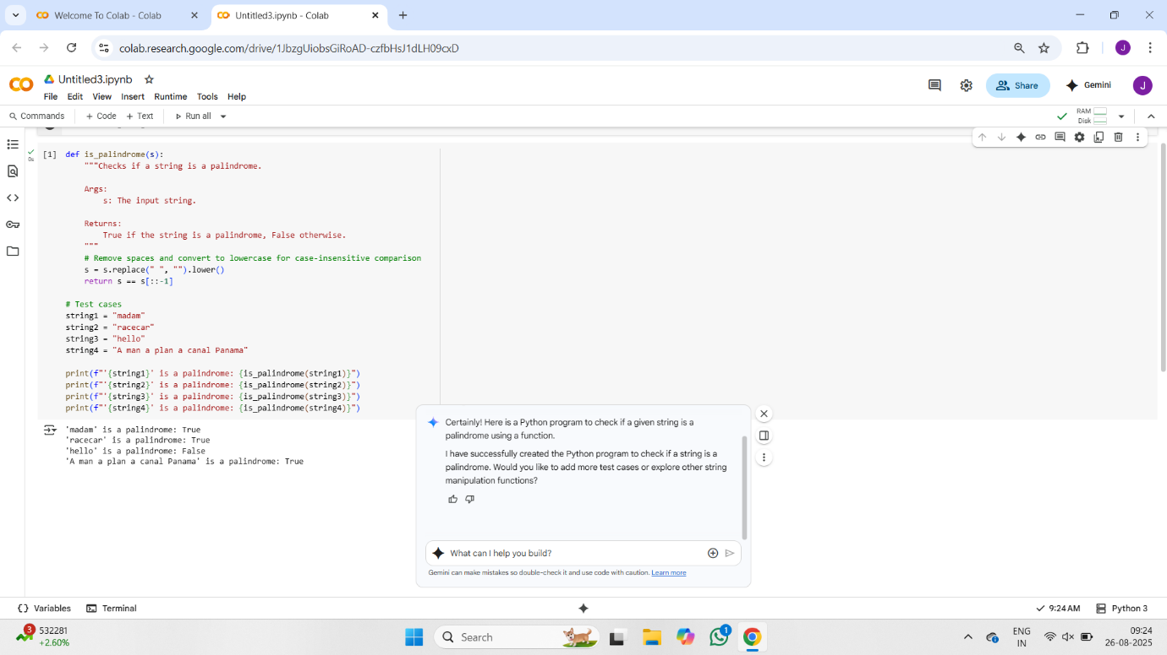

Code explanation: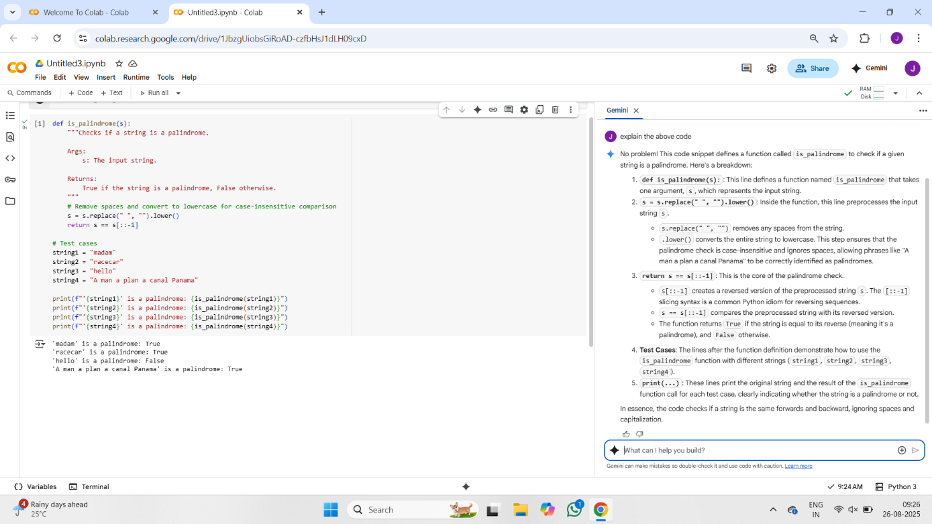

2.WRITE A PYTHON PROGRAM TO FIND THE LARGEST AND THE SMALLEST NUMBERS BY USER PROVIDED LIST AND ASK GEMINI TO GIVE STEP BY STEP EXPLANATION OF CODE

CODE:

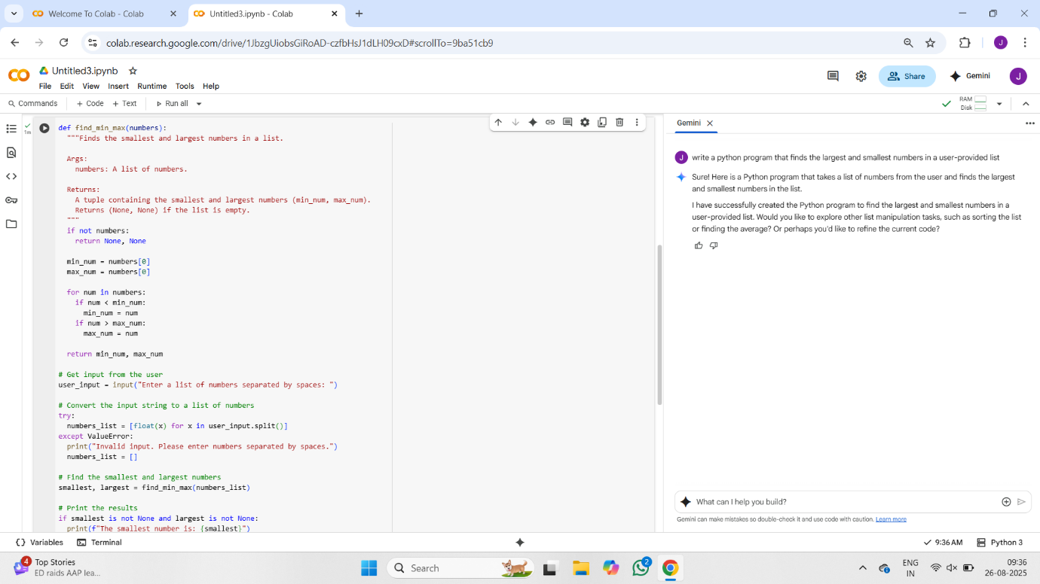

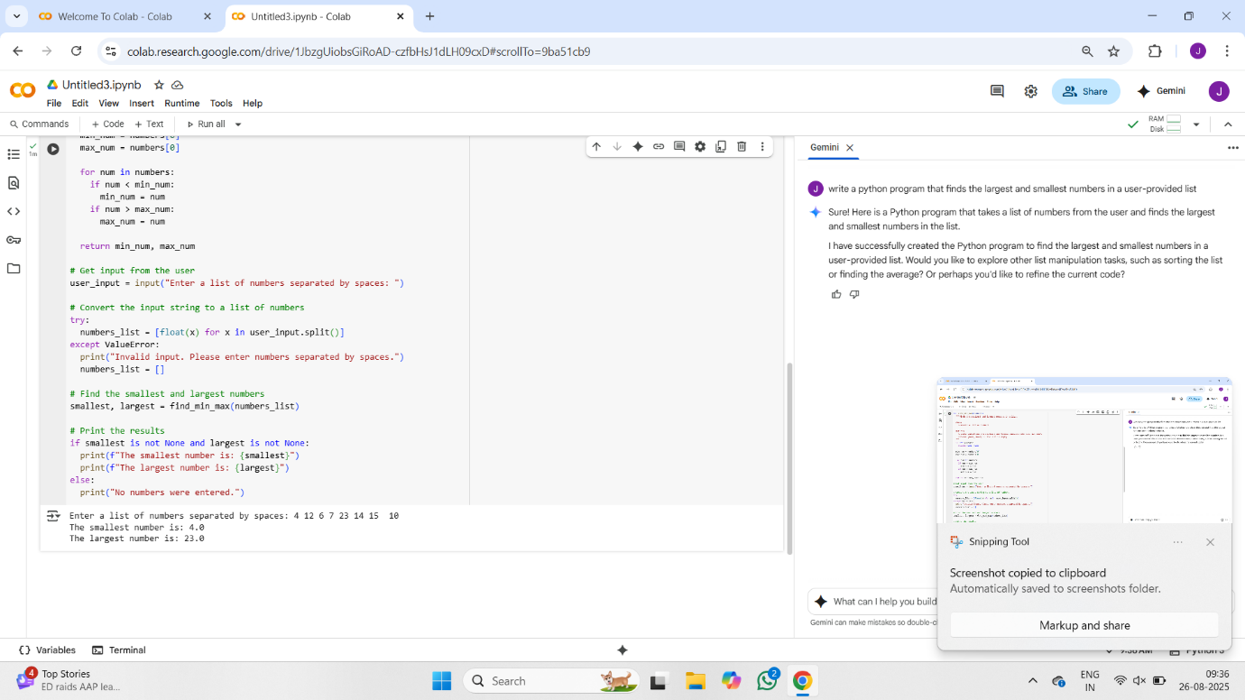

CODE EXPLANATION:

